|  |
| --- |
| **DV SQUARE Production.** |
| Rocket Man |
| **Space Invaders Replica** |
| Version 1.0  All work Copyright © 2020 by **DVSquare Production**.  All rights reserved. |
| **Dhimant Vyas** |
|  |

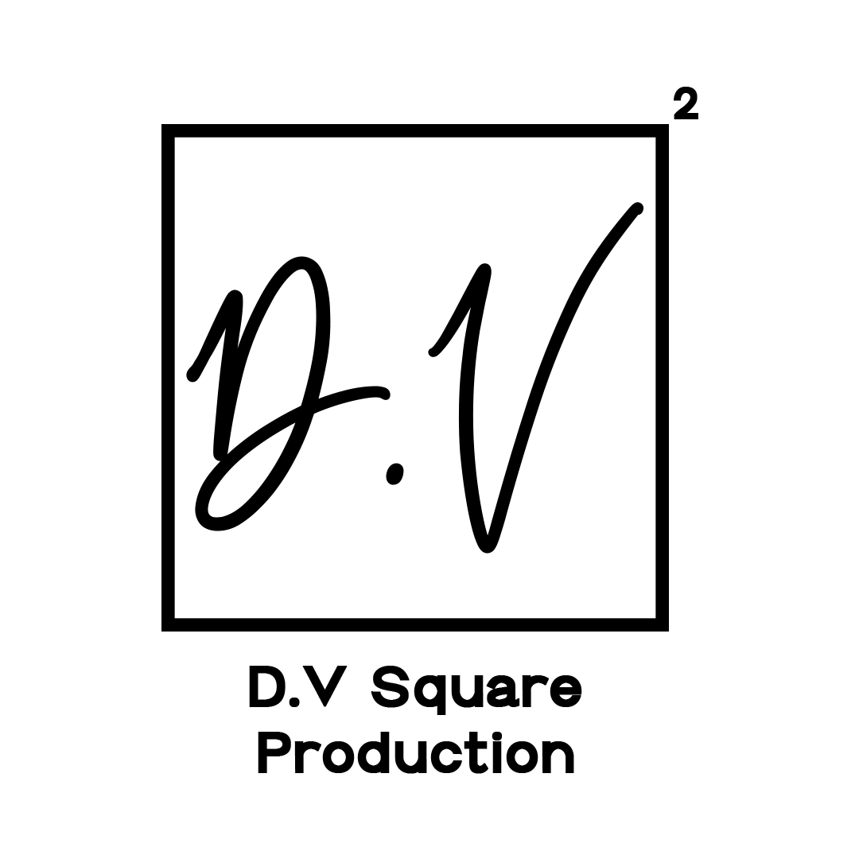

|  |
| --- |
| September 23rd 2020 |

**Table of Contents**

[

1. **Version History**

1. **Game Configurations**
2. **Game Overview**
3. **Game Play Mechanics**
4. **Camera**
5. **Control**
6. **Saving and Loading**
7. **Interface Sketch**
8. **Menu and Screen Descriptions**
9. **Game world**
10. **Levels**
11. **Game Progression**
12. **Enemies**
13. **Weapons**
14. **Script**
15. **Scoring**
16. **Sound Index**
17. **Story Index**
18. **Art/Multimedia Index**
19. **Future Features**

**Version History**

[

Version 1.0 = Created GitHub Repo (15th September)

Version 1.1 = Added Buttons (22nd September)

Version 2.2 = Added Assets (25th September)

[

1. **Game Overview**

*Rocket Man is going to be a Space shooter game like Space invaders. As it is going to be scrolling background there is no Win situation, but Player can make the high scores.*

1. **Game Play Mechanics**

*Rocket Man is a scrolling background game where player can shoot enemies and can make a high score. There will be a losing case but no winning case.*

1. **Camera**

*Camera is going to be a 3rd Person View. Where Player can see the character on top view.*

1. **Controls**

*Joypad on the left side of the screen will be used to move the player and a shoot UI on the right side of the screen will be used for shooting.*

1. **Saving and Loading**

*As it is a scrolling game there is not going to be any loading or saving.*

1. **Interface Sketch**

*Game Screen Interface*

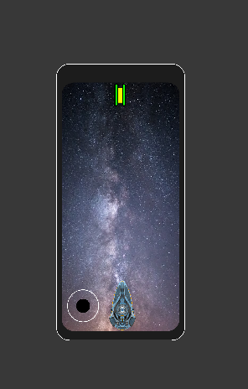

1. **Menu and Screen Descriptions**

*(Include additional screen shots and accompanying descriptions for any menus and additional screen)*

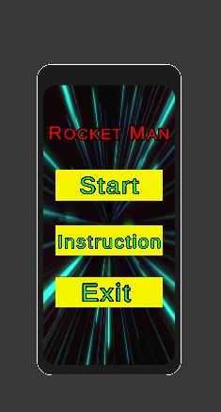 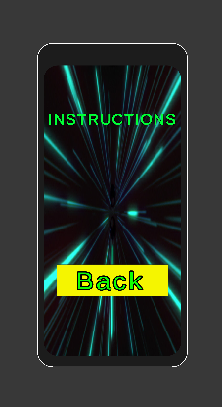 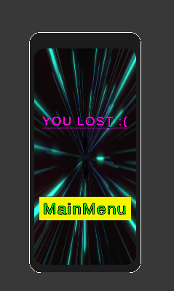

1. **Game World**

*Game Environment will be a scrolling background with two types of enemies.*

1. **Levels**

*There is only going to be one Level.*

1. **Game Progression**

For the alpha of this game it will be running on the simple pace.

1. **Enemies**

*As of right now player will be able to kill two kind of enemies. One will be simple rocks coming in the way of player which will not have any AI component. And the other enemies will have Line of sight AI to find player and fire at him.*

1. **Weapons**

*There is going to be only one type of bullet for now. In future I may implement more bullets with different effect on enemies. Player will be able to get those kinds of bullets when killing enemies.*

1. **Script**
2. **Scoring**

Scoring will be implemented with time. Every second player stays alive he will get one point.

1. **Sound Index**

*There are two kinds of soundtrack in game with some sound effects.*

*Soundtracks are used in Main menu, Game state, Instruction menu, Pause state and lose state.*

*Soundtracks:*

**

1. **Story Index**

*You are a person in your Rocket ship killing all the obstacles coming in the way to go back to your own planet.*

1. **Art / Multimedia Index**

*Player Spaceship*

*Enemy*

*Rocks (Hazard)*

*Bullet*

1. **Future Features**

*More Bullet Effects*

*More enemy types.*